Solution Architecture Document – Dynamics 365 CE

<Date>
Version 1.0

Document Revision History
Version | Author(s) | Changes
1.0 | <Name of the Author> | Version 1 of the document

Table of Contents
Document Revision History 1
Glossary 4
Functional Architecture - Target State 5
Solution Blueprint​ – Target State 6
Execution Architecture​ 7
D365 CE Instance 7
D365 Instance Architecture 10
Development Architecture​ 15
Development Processes 15
D365 Application Lifecycle Management 20
Development Tools 22
Operation Architecture​ 23
Power Platform Admin Center 23
High Availability & Disaster Recovery 28
Non-Functional Requirements​ 31
Annexure​ 31
Coding Standards and Best Practices 31

Glossary
Term | Definition
D365 CE | Microsoft Dynamics 365 Customer Engagement is Dynamics CRM solution
UI | User Interface
CDS | Common Data Service is base set of standard entities that come with D365
SSIS | SQL Server Integration Services
ODS | Operational Data Store is our custom DB that replicated D365 data on azure sql
NFR | Non-Functional Requirements
O365 | Office 365
DLP | Data Leak Protection
CRUD | Create Read Update Delete Operations
OOB/OOTB | Out of the Box
DC | Data Centre
HA | High Availability
VMSS | Virtual Machine Scale Set are groups of individual VMs within Azure that can be configured & managed as a single unit
SLB | Software Load Balancer
LRS | Local Redundant Storage replicates data within a single physical location in the primary region
GRS | Geo Redundant Storage copies data synchronously within a single physical location in primary region and then copies the data asynchronously to a single physical location in a secondary location (away from primary region)
TDD | Technical Design Document is the detailed design document that will be prepared during project
SDK | Software Development Kit is a collection of software development tools
VS | Visual Studio is the integrated development environment for our .Net development
SIT | System Integration Test is the overall testing of a complete system
UAT | User Acceptance Test is the business acceptance test
AUI | Automated User Interface Test is the automated test of manual test tasks

Functional Architecture - Target State
<This section describes the key functional capability of the solution. At a high level it shows the core modules, key integrations and features.>
D365 state architecture will be comprised of the following key capabilities -
- Dynamics 365 Field Service – Core platform & UI for end users
- Power Automate – Enables integration & executes workflows
- Customers Source / Target Systems – Existing enterprise systems
- Integrated Azure Apps – SharePoint Online for document management

Figure 1: Capability View by Layers (Conceptual)
User Interface
This layer is built on D365’s Unified Interface and it provides interface for the end user to interact with the application. The interface is rendered in web browser and it supports all the modern browsers – Microsoft Edge, Google Chrome, Apple Safari & Mozilla Firefox. Refer official documentation for latest supported browsers(https://docs.microsoft.com/en-us/dynamics365/customerengagement/on-premises/admin/web-application-requirements)

Customer’s custom solution is built by extending the D365 Field Services module. Other D365 solutions that are included in the solution are as follows (these are modules/add-ons that are layered as individual solutions within D365 instance):
- Customer Voice
- DocuSign for D365

Business & Solution Capabilities
<Explain each functionality briefly>

Integration
This layer enables integration with the other Customer enterprise platforms. It is a decoupled architecture where there is no point to point connectivity between D365 & Enterprise applications.

Source Systems (Data)
This layer comprises of the various source systems of Customer that will provide the data capabilities presented at the D365 layer.

Solution Blueprint​ – Target State
Target state solution blueprint will be comprised of the following key components -
- Components on Azure Cloud
  - Dynamics 365 Field Service
  - Authentication Provider (Office 365)
  - Document Management (SharePoint Online)
  - Integration (Power Automate)

Figure 2 shows the various components

Figure 2: Solution Blueprint

- Components at Customer Datacenter
<Introduce each on-prem application, data that will be exchanged and the integration protocol>

Execution Architecture​
Execution Architecture is concerned with creating the environment in which technology solutions run. It is a unified collection of run time technology services, and supporting infrastructures upon which application software runs.

D365 CE Instance
D365 CE allows options for segregating the Customer Engagement apps data and user access. For most companies, adding and using multiple instances in the subscription provides the right mix of functionality and ease of management. Multiple instances can share users among instances; multiple tenants cannot.

Terminology
Term | Definition
Tenant | For D365 CE apps, a tenant is the account you create in the Microsoft Online Services environment when you sign up for a Customer Engagement apps subscription. A tenant contains uniquely identified domains, users, security groups, and subscriptions and can contain multiple Customer Engagement instances.  The tenant created for you has a domain name of <account>.onmicrosoft.com. For example, contoso.onmicrosoft.com.
Instance/Environment/Org | When you sign up for a trial or purchase a D365 CE apps subscription, a Customer Engagement apps Production instance is created. Each additional Production or non-Production (Sandbox) Customer Engagement instance you add creates a separate and isolated D365 CE apps organization on the same tenant.
Multiregional instance | An instance in a different region than where your Customer Engagement tenant resides. Local instances can provide quicker data access for users in that region.
Subscription | A subscription consists of the Customer Engagement apps licenses and add-ons included with the trial or paid service you signed up for in your Customer Engagement apps account. Customer Engagement apps subscriptions can vary in license type, price, and end date.  For example, a subscription might be 100 licenses of D365 CE apps Professional and 10 licenses of D365 CE apps Enterprise.
Identity | The user account used to sign in to Customer Engagement apps. You can also use this identity to access other Microsoft Online services, such as Office 365 or SharePoint Online. Administrators can decide if they want to federate user identity management between Customer Engagement apps and on-premises Active Directory.
User account | A user account assigned by an organization (work, school, non-profit) to one of their constituents (an employee, student, customer) that provides sign-in access to one or more of the organization’s Microsoft cloud service subscriptions, such as Exchange Online or Customer Engagement apps. Access to an online service is controlled by the license assigned to the user account.  User accounts are stored in an organization’s cloud directory within Azure Active Directory, and are typically deleted when the user leaves the organization. Organizational accounts differ from Microsoft accounts in that they are created and managed by admins in the organization, not by the user.
Security group | If your company has multiple Customer Engagement instances, you can use instance security groups to control which licensed users can access a particular instance.

Refer to below link for additional details:
https://docs.microsoft.com/en-us/dynamics365/customer-engagement/admin/multiple-online-instances-tenants

Other important considerations
- Each instance within the tenant receives its own SQL database
- Customer Engagement apps data is not shared across instances
- D365 CE Storage is shared across the primary instance and any additional instances
- All instances for a single customer tenant will be set up in the geography where they initially signed up for their account. Storage consumption is totaled and tracked across all the instances attached to a customer tenant. For CUSTOMER this will be the Canada Central data center
- We can set up separate security groups for all instances.
- A licensed Customer Engagement apps user can potentially access all the Customer Engagement instances associated with the tenant.
- On-premises Active Directory federation cannot be established with more than one tenant unless we have top-level domains that we need to federate with different tenants

D365 Instance Architecture

Instance model at Customer (Production)
1) Tenant – customerdomain.ca
- Number of D365 Instances in production – One (Single instance deployment)
- Deployment Region – Canada
- Modules & Microsoft add-ons – these are installed as solution on the D365 instance:
- Field Service module
- Customer Voice
- Non-Microsoft add-ons – these are installed as solution on the D365 instance:
- DocuSign for D365

D365 instance drill down
Figure 3: D365 application architecture

- D365 has a 3-tiered model with well defined physical roles. Each role can independently scale up and scale out with SQL scaleup
- There are extension capabilities at every horizontal layer which are represented by Cogs in the figure above
- Multiple types of extensibility paradigms to appropriately choose from. Each option will be evaluated in the detailed design phase of the project to build custom components
  - Rich API (Web Services, ODATA)
  - Business User (Rules, Calculated Fields, Process Flows and more)
  - Developer (Full .NET SDK) with access to the transactional pipeline
- Workflow APIs are exposed for extending the workflow solutions. Another pattern to extend Workflows is use of Power Automate, which will be our preferred method at Customer
- More than one Client-side integration option to choose from. Each option will be evaluated in the detailed design phase of the project to build client side integrations
  - Mashups
  - Javascript

D365 Data Segregation
To understand the Data segregation, it is important to understand ‘Scale Group’.
- Each Scale Group is a single deployment of Common Data Service platform software, it hosts single version of software
- It is a Shared infrastructure to provide maintainable and scalable infrastructure set
- Hosts multiple customer organizations each with their own database but shared service infrastructure. It is Important to note that every Org in the Online System gets an isolated SQL Database
- How many customers are hosted depends typically on variables such as #users, data volumes and is calculated automatically
- Each scale group hosts combination of sandbox and production orgs, and also from different customers
- It has following Azure hosted resources:
  - SQL Azure
  - VM Scale Sets

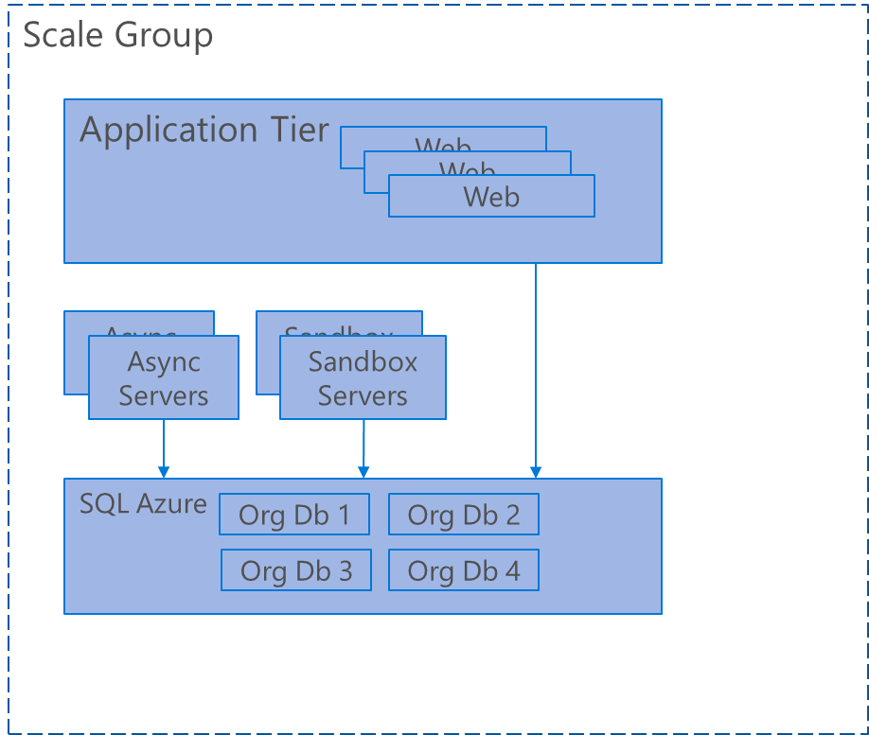
Figure 4: Scale Groups

Scale Group Architecture

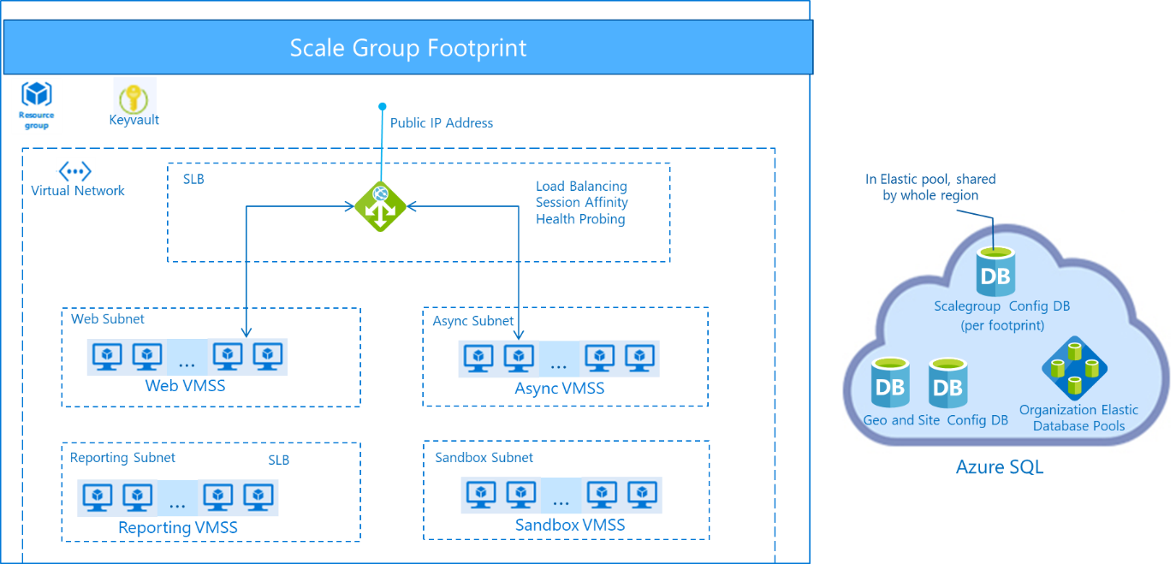
Figure 5: Scale Group Architecture

D365 Data Segregation
There is a segregation to DB level as shown below. Every Org in the Online System gets an isolated SQL Database. The SQL Database as well as the Core CDS Servers that process this data are isolated to a Geography.
Figure 6: Data Segregation in D365

Data Gateway
The on-premises data gateway acts as a bridge. It provides quick and secure data transfer between on-premises data and several Microsoft cloud services that Power Apps, Power Automate. Gateway enables ability to keep databases in the on-premise network while securely using that on-premises data in cloud services. It is installed in the on-premise network by the Admin.
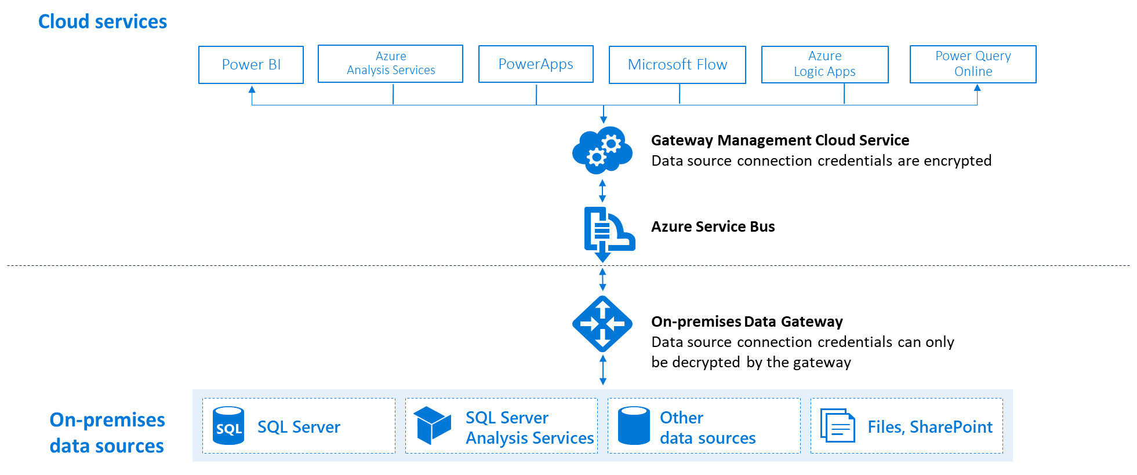
Figure 7: Data Gateway Architecture

There are two different types of gateways, each for a different scenario.
On-premises data gateway: Allows multiple users to connect to multiple on-premises data sources. With a single gateway installation, we can use an on-premises data gateway with all supported services. This gateway is well-suited to complex scenarios where multiple people access multiple data sources.
On-premises data gateway (personal mode): Allows one user to connect to data sources and can’t be shared with others. An on-premises data gateway (personal mode) can be used only with Power BI. This gateway is well-suited to scenarios where an individual is the only one who creates reports and that individual does not need to share any data sources with others.
Requirements & Important Limitation to consider (for Data Gateway):
- Minimum requirements
- .NET Framework 4.6 (Gateway release August 2019 and earlier)
- .NET Framework 4.7.2 (Gateway release September 2019 and later)
- A 64-bit version of Windows 8 or a 64-bit version of Windows Server 2012 R2

- Recommended
- An 8-core CPU
- 8 GB of memory
- A 64-bit version of Windows Server 2012 R2 or later
- Solid-state drive (SSD) storage for spooling.

- Related considerations
- It is recommended to install gateway in Standard mode (not the personal mode).
- Power Apps and Power Automate support both read and write operations through the gateway:
- Write operations have a 2-MB payload limit.
- Read operations have a 2-MB request limit and an 8-MB compressed data response limit.
- URL for the GET request has a 2048 character limit.
- Gateways aren't supported on Server Core installations.
- The user installing the gateway must be the admin of the gateway.
- The gateway can't be installed on a domain controller.
- If gateway uses Windows authentication, it must be installed on a computer that's a member of the same Active Directory environment as the data sources.
- It is not recommended to install a gateway on a computer, like a laptop, that might be turned off, asleep, or disconnected from the internet. The gateway can't run under any of those circumstances.
- It is not recommended for a Gateway to use a wireless network, it has performance impact.
- It is not recommended to install other applications on the gateway machine (technically we can) as this may degrade gateway performance. If we do install other applications on the gateway machine, we must monitor the gateway closely to check if there's any resource contention.
- Data gateway does support following connectors (list trimmed as per our project requirements):
  - REST APIs via any custom connectors that we will create
  - File System
  - Http with Azure AD
  - MySQL
  - SharePoint
  - SQL Server

Development Architecture​
Development Architecture specifies the processes, and tools necessary for a project to enable custom and packaged application development. At a high level, a definition of development architecture is responsible for specifying resources necessary in support of development, testing, quality assurance, deployment, and team collaboration.

Development Processes

Solutions
Solutions are used to author, package, and maintain units of software that extend D365 CE. They are distributed to organizations so that they can use D365 CE to install and uninstall the business functionality defined by the solution. Consider them as containers for components of the application which act as the unit of transport to enable applications to be moved between environments.
They are used to ensure all new components have a standard naming prefix and are the mechanism to author, package, maintain and distribute functional configuration and custom code that extends the behavior of D365 CE apps.
Solutions can never be exported from a higher version & imported on a lower version. Vice versa is possible.

Solution Components
Solutions consist of – Entities, User Interfaces, Analytics, Process/Code, Templates, Security.
Solutions do not contain - Business Units, Users, Teams, Queues, Goals, Subjects, product Catalogue, Personal Views, Personal User settings.
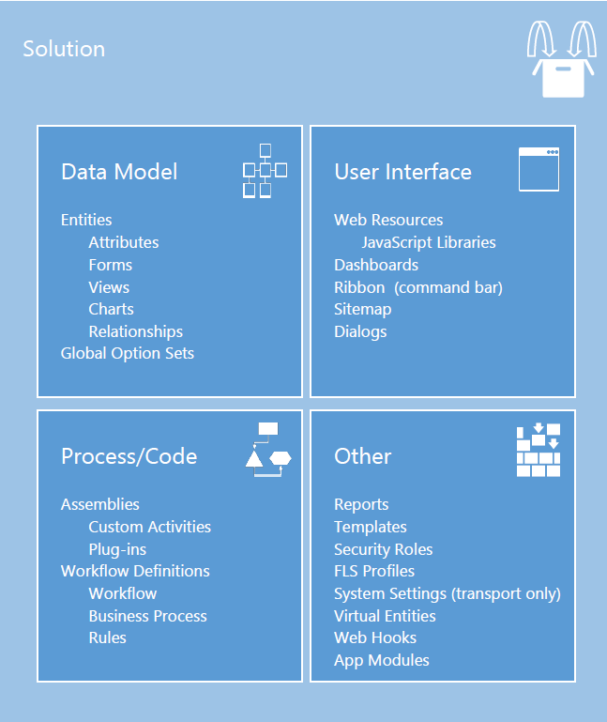
Figure 8: D365 CE Solution Composition

Solution Packages/Types
D365 CE Solutions can be of two types – Managed & Unmanaged

- Unmanaged Solutions: Analogous to application source code and to be used for development purposes only – to act as a container for unmanaged customizations and to transport between development instances.
- Managed Solutions: Analogous to compiled application binaries – to be deployed (imported) into any instances downstream of development environments. Also, to be deployed within development instances where used as a common library providing base capability that will be extended for a discrete purpose or implementation.

Proposed Solution Strategy at Customer

Proposed Approach | Comments
Use Managed Solutions in downstream environments (everything beyond Development) | Managed solutions are in a lock down stage which means no changes can be done directly on Production instance
UAT, SIT & Staging environments should be architecturally and functionally representative of the production environment | The approach to deployment within these environments should be representative of the deployment to production. Rest the environments to keep in sync.
Use Solution Segmentation | Minimize the likelihood of collisions when developing and merging solutions. It also avoids the introduction of unnecessary dependencies
Patching/Cloning approach to update Managed solutions for production issues | Minimizes dependencies by only including impacted component in patch. Is layered just above the Parent solution (from which patched)
Figure 9: Proposed Solution Strategy

Proposed Solution Layering at CUSTOMER
Each of the below will be a separate Physical solution in the D365
Solution Layer depth | Physical Solutions | Solution Components
1 | Dynamics Project Name | All configurations & Customizations made under project <Project Name>
Figure 10: Proposed Solution Layering
Other important guidelines:
- Separate publisher for Avanade Customizations during the implementation
- CRM customizations must always be exported and committed to the repository
- Synching of higher instances would be one way from DEV instance
- Developers should deploy their code in the DEV organization and test it before proceeding with the code promotion
- All code developments and customization changes must follow the code promotion process, i.e. a pull request (code review) is sent by the customizer or developer and after the pull request is approved and pushed to the target branch (usually master), a build is triggered and the deployment through the different stages is started
- A guard build must be set up to validate every push to any branch (also the user or feature branches) to get early quality feedback

Proposed Development Instance Strategy at CUSTOMER
Instances in D365 CE online can be either Production or Sandboxes. Sandbox instances are similar to Production instances in terms of the hardware and support given by Microsoft. Besides the top toolbar embossed with “SANDBOX” there are a few administrative differences in the Sandbox & Production instances –
- Copy Instance – Platform provides a capability to copy an instance & restore it on a target. This target cannot be a Production instance
- Delete Instance – Production instance cannot be deleted unless converted to a Sandbox
- Reset Instance – Cannot be done for production instances (resets the instance to factory settings wiping off all data)
- Admin mode instance – Cannot be done for production instances
Switching instances & Backing up instances are no different between Production & Sandboxes.
At Customer the CRM instances will be federated with customerdomain.ca domain.
To provision a new D365 CE instance, request a D365 CE Online sandbox instance through Customer Technology and Operations Team. Individual developer user Ids to be provisioned in customerdomain.ca domain.

Development Instances at CUSTOMER
Development instances closely align with the number of CRM Solutions in the project and with number of parallel development work streams.
Every CRM solution needs an isolated instance where the solution is deployed in Unmanaged state for development. Any solution which will be layered “under” this solution in production are deployed as Managed within the instance to ensure development is done on the right base.
It is recommended that CRM instances be provisioned as follows for development:
Instance Name | Purpose | User Group | Test Scope | Data
DEV | Main development instance with all the Configurations & Customizations | Developer | Development, Unit test | Test
DEV-INT | Build verification | Developer | BVT, Automated UI tests (future) | Test
DEV-TEST (SIT) | SIT & ORT | Dev Team / Accenture Test team | SIT, ORT, Regression test | Test
BAT | Verification by CUSTOMER team. User Story BAT & End to End BAT | CUSTOMER Test team | Business Acceptance Test | Production near data
TRAINING | Demo, Training of end users | CUSTOMER Change Management Team | - | Production near data
PRE-PROD | Verification by CUSTOMER team | ? | - | Production near data
PRODUCTION | Productive environment | CUSTOMER end users | - | Production data
DEV-DM | Data migration build & runs | Development team (Data migration team) | Migration dry runs | Migrated data from Source
Upgrade Instance | Early opt in for upgrades to test & validate | CUSTOMER Test team | Regression, Automated UI tests | Production near data
Figure 1: D365 Instances

D365 Application Lifecycle Management

Solution Deployment process
Figure 12: Deployment approach
- Source control always has latest copy (Golden copy) of the solution
- All artifacts deployed to DEV-INT and upper environments will originate from the repository (ideally directly from the pipeline)
- There is only one single Customization & Development environment
- Customizations & developments including unit tests will only be done in the DEV environment and the customizations will be synchronized to the repository using Azure DevOps jobs
DEV-INT is the organization in which managed solution is layered. In the future this instance can be pointed for all automated tests

Branching
Branching depends on multiple factors including:
- Complexity of projects in terms of releases (parallel stream), functional and multi geography development.
- Size and maturity of the development team
Based on that, there are various possible branching strategies.
The recommendation for CUSTOMER project is a trunk-based branching strategy which also known as centralized workflow. This is the recommended branching strategy for projects where all work can happen or be bundled in one release stream at a time. This approach is based on the principle of one master trunk which is the single source of truth. Every commit will happen on it.
The figure below demonstrates how this will be implemented in the project.

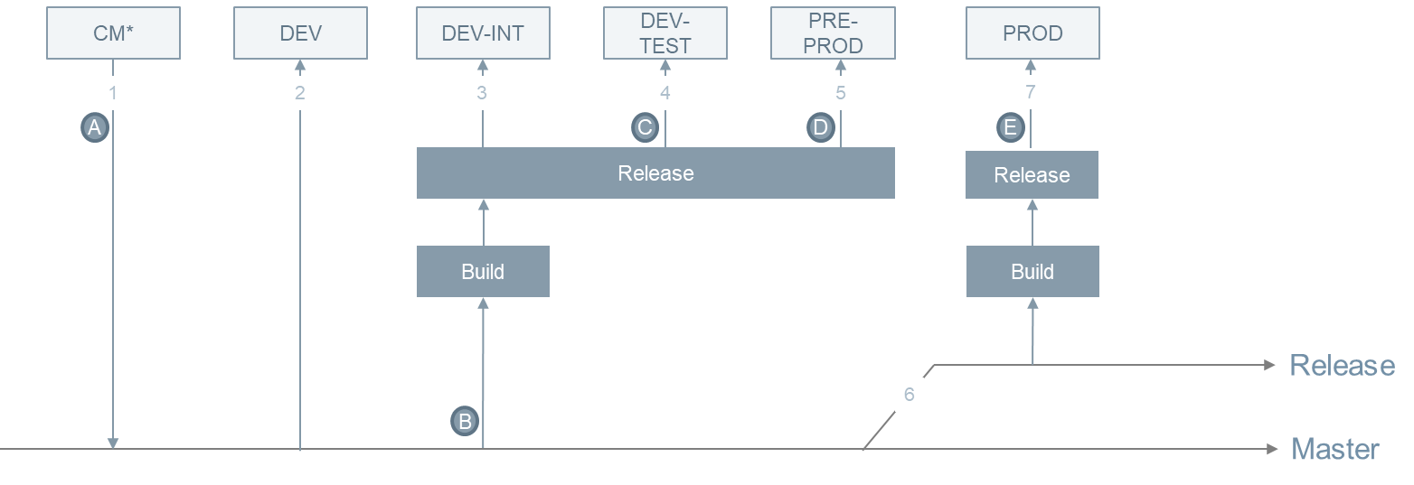
Figure 13: Branching
- Configurations (customizations in MS nomenclature) are only done in the Customization Master (CM) environment and committed to the repository
- DEV organization must be kept in sync with the CM organization (in terms of configuration and customization), preferably via Automation. Code is developed in Visual Studio and pushed to DEV via scripts or manual builds and committed to the repository
- After a commit (when a pull request is approved), the artifacts are built and published to DEV-INT if the unit tests and code quality metrics are green
- Upon manual approval by the developer (to avoid that too many check-ins cause too many automated deployments disturbing the tests), the same artifacts are published to DEV-TEST where the iteration tests can be performed
- At the end of the iteration (or earlier if previews are agreed with the functional stakeholders), the artifacts are published to PRE-PROD for demo and end user testing
- After the final release demo and acceptance, a release branch is created which can be used to cherry-pick commits if hotfixes are required (otherwise, changes are constantly committed to the main branch so that no fixes are forgotten to be merged).
- The final artifacts are built and published to PROD

Main Principles
- All code, CRM configurations and data (configuration and test data) must be committed to the repository
- There must be a master branch (main branch) which must have only stable and tested code checked in/committed
- Every check-in in feature branch must be tested and validated before the commit
- Prefer Git over TFSVC or SVN, as git branches are lightweight and provide a better management of source code
- The release branch must target the production environment and the master branch must target all environments, except production
- Last couple of releases will continue to live in the respective release branches (storage consumption is not an issue in Git) and it is up to the project to decide if the branches are cleaned up after tagging the related commit
- Only hotfixes must be added to the productive release branch, new features must not be added.

Development Tools
The following are developer tools and resources that are required for D365 developers:
SDLC Task | Tool | Description/Comments
Orchestration | Azure DevOps Services | Center of the project development activities.  Project Link:
Development | - D365 CE SDK tools from NuGet  - Visual Studio 2019  - Visual Studio Code  - NuGet, npm  - Dynamics SDK  - XRM Toolbox  - Postman  - CRM REST builder | - D365 CE SDK tools from NuGet:  https://docs.microsoft.com/en-us/dynamics365/customerengagement/on-premises/developer/download-tools-nuget  - XRM Toolbox:  https://docs.microsoft.com/en-us/dynamics365/customer-engagement/developer/developer-tools  - Postman:  https://docs.microsoft.com/en-us/dynamics365/customer-engagement/developer/webapi/use-postman-web-api  - CRM REST Builder:  https://github.com/jlattimer/CRMRESTBuilder
Unit Testing | - MS Test  - Fake XRM Easy  - Jest | - Fake XRM Easy Unit testing library:  https://github.com/jordimontana82/fake-xrm-easy  - Jest JavaScript Unit testing:  https://docs.microsoft.com/en-us/visualstudio/javascript/unit-testing-javascript-with-visual-studio?view=vs-2019
Code Quality | VS Code analysis
Repo | Azure DevOps Repos (git) | Project Link:
Build & Release | Azure DevOps Market extensions | https://marketplace.visualstudio.com/items?itemName=microsoft-IsvExpTools.PowerPlatform-BuildTools
Figure 16: Development Tools

Operation Architecture​
This section describes common Operations Environment Services that are available to administrators and help desk staff when adding licenses to users, applying product updates, investigating outages, monitoring the disk space used, and adding additional functionality to D365 CE.
This is done through Power Platform Admin Center for managing the implementation at a system-level
All other network/system management, service management, physical site management, etc. are the responsibility of Microsoft who owns the hardware.
When AD Sync is configured with Azure and Office 365 (O365) users will appear automatically in the user list. This is by synchronized every hour by default. The D365 CE licenses aren’t assigned automatically. An O365 Administrator must assign the licenses. There are ways to script this using PowerShell if necessary.

Power Platform Admin Center
The Power Platform Admin Center allows an administrator to manage D365 environments at the system level. The Administration Center is available here:
https://admin.powerplatform.microsoft.com/
Currently, the admin center provides the following capabilities.
- Environments: View, create, and manage your environments. Select an environment to see details and manage its setting
- Analytics: Get a detailed view of key metrics for Power Platform apps. View Common Data Service analytics to quickly view adoption ad user metrics for your organization
- Resources: View all the D365 apps, portals & capacity utilization
- Help + support: Get a list of self-help solutions or create a support ticket for technical support
- Data integration: Access to Data Integrator, it is a point-to-point integration service used to integrate data into Common Data Service
- Data gateways: Access to Data gateway which enables data transfer between on-premises data and cloud services
- Data policies: Build & enforce Data Loss Prevention (DLP) policies
Further details on each of these can be accessed at https://docs.microsoft.com/en-us/power-platform/admin/admin-documentation

Environments
The Environments page lists all the provisioned environments along with the Type (Production, Sandbox, Trial) and Region where the environment is provisioned.
New environments can be created by using the ‘New’ option on the ribbon bar.
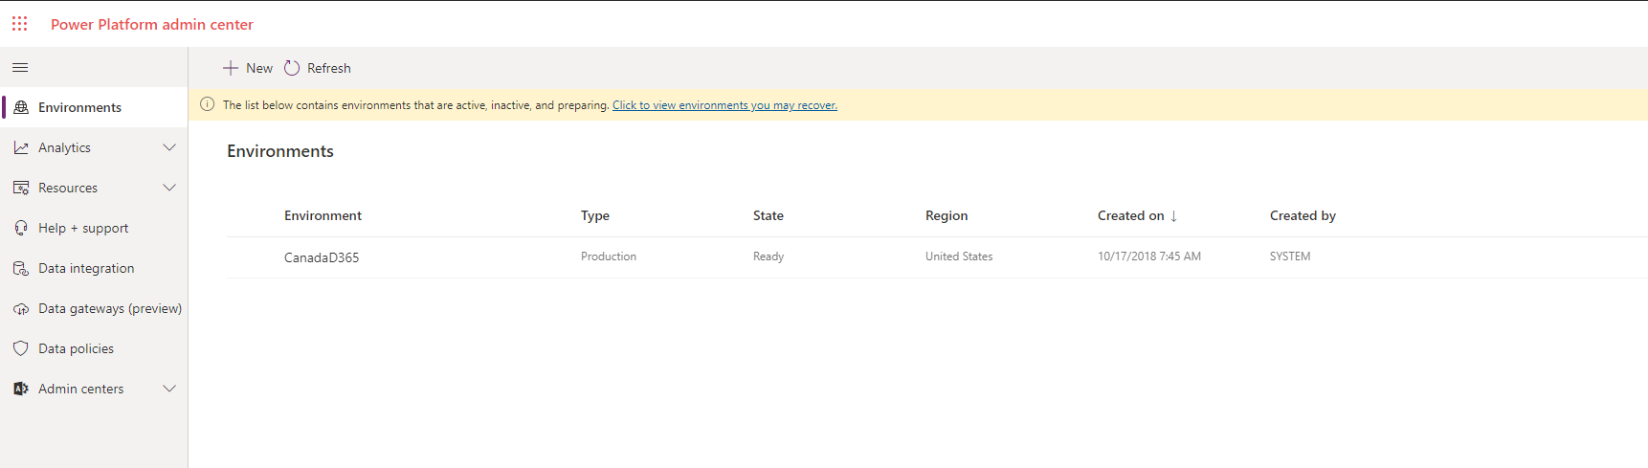

Updates
Updates to the environment can be managed through admin center. D365 offers two major releases per year (April & October). We propose CUSTOMER should opt for early access to self-update to the new release and start testing and validating the new features before they're automatically enabled for the users. One dedicated instance is proposed for it.
Few important points to note:
- All available updates to CUSTOMER’s environment will be initiated at once
- After they're enabled, the updates can't be reverted. It is recommended to update sandbox environment before updating the production environment
- Only the apps that CUSTOMER currently has licenses for will be updated; no new apps will be installed as part of upgrades

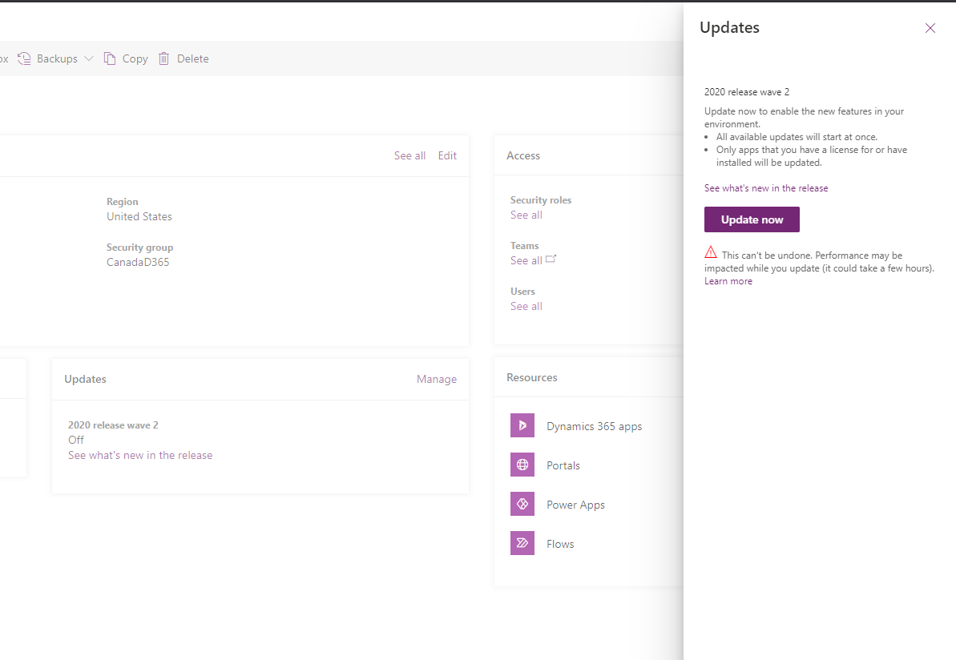
Figure 20: D365 CE Product Updates

Platform Monitoring
Tab Analytics à Common Data Service shows the key stats & current health of the instance. Amount of space/storage being used can be accessed at Resourcesà Capacity
Admin monitoring covers following areas:
- Active Users – Shows data on number of active users & data around CRUD operations performed by users
- Mode of Access – Breaks down the usage stats by device, OS, security roles
- Entity Usage – Lists the most used Custom & OOB entities
- System Jobs – Data on system jobs
- Plug-ins – Data on Plugins
- API call statistics – Data on API calls
- Mailbox usage
The observation period can be narrowed down by using appropriate filters.
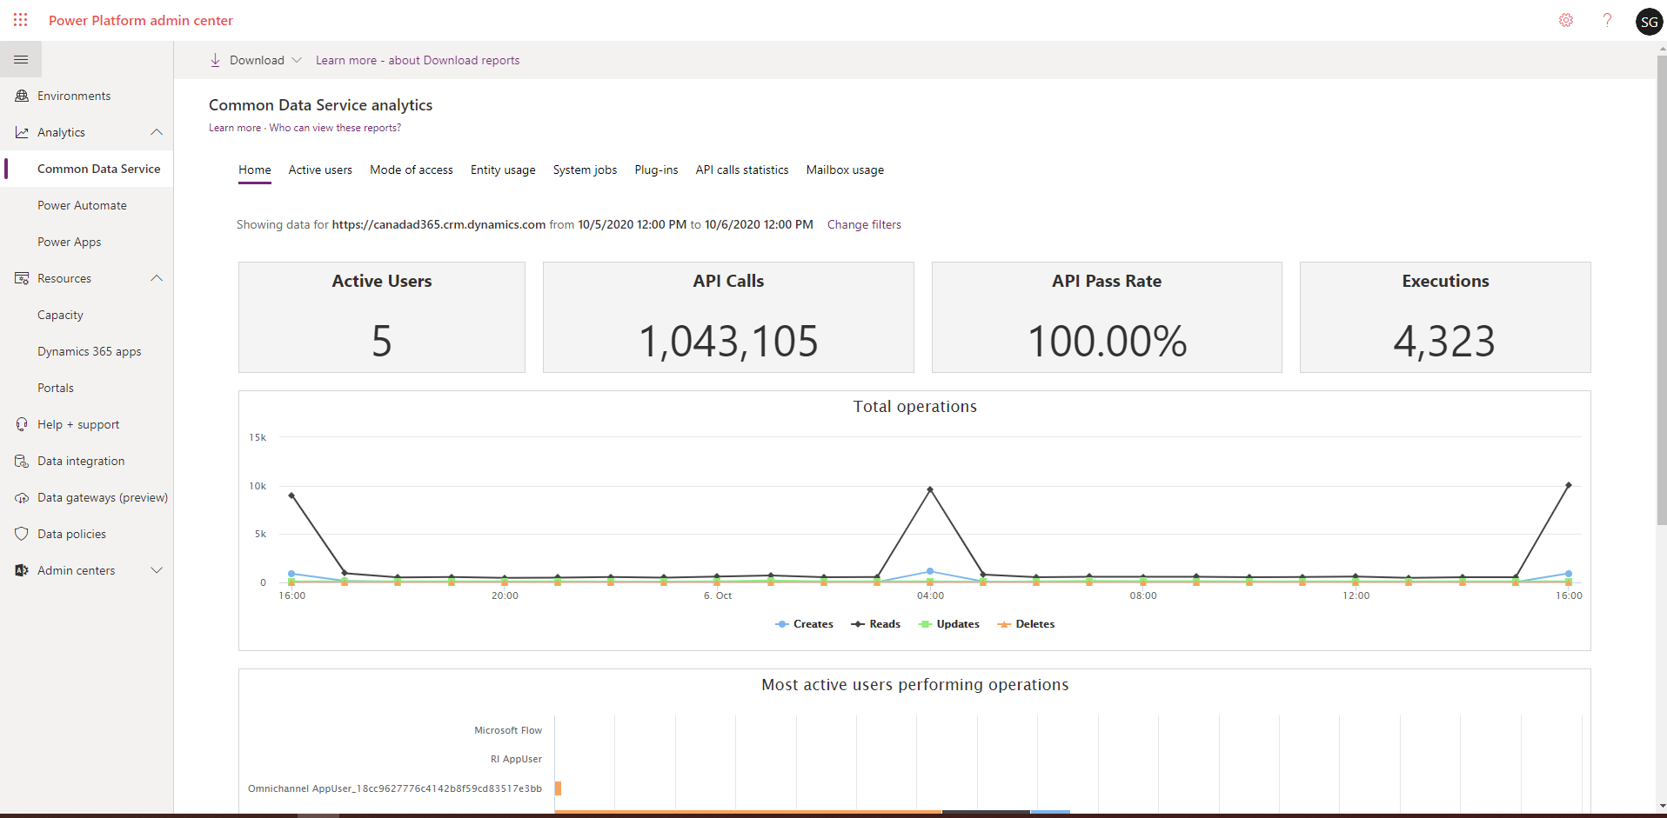
Figure 21: Platform Key Stats

Backups
D365 CE automatically backs up the database (instance) every night. An administrator can also force backups to occur and then restore the system to that backup.
This can be useful when reverting the system to a known state after running potentially destructive bulk deletes against the system.

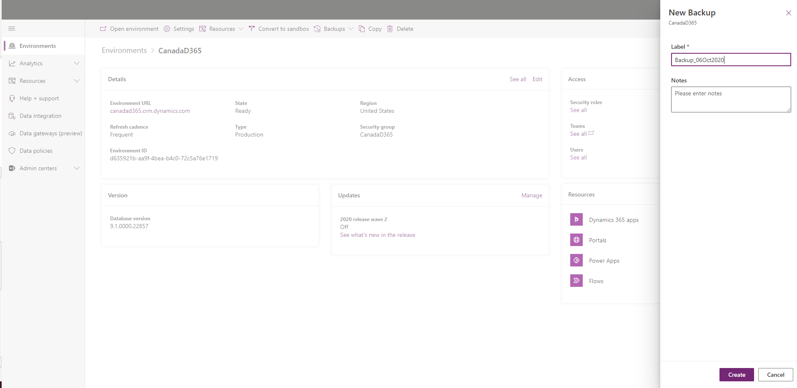
Figure 22: Manual Backup

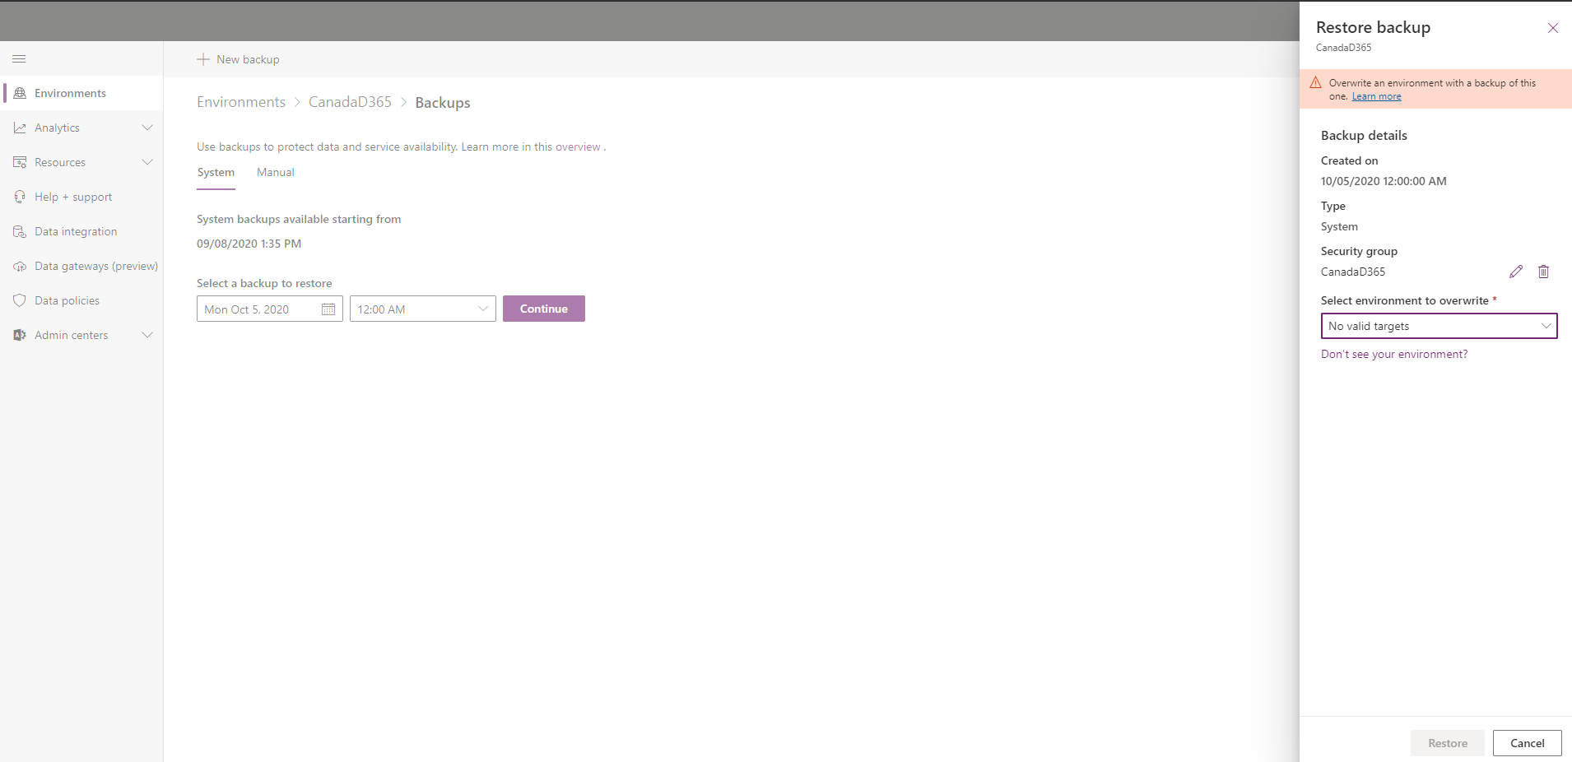
Figure 23: Restore Backup

Dynamics 365 Apps
D365 CE also includes a number of packaged applications that can be added. These are enabled by default but not utilized until they are required.
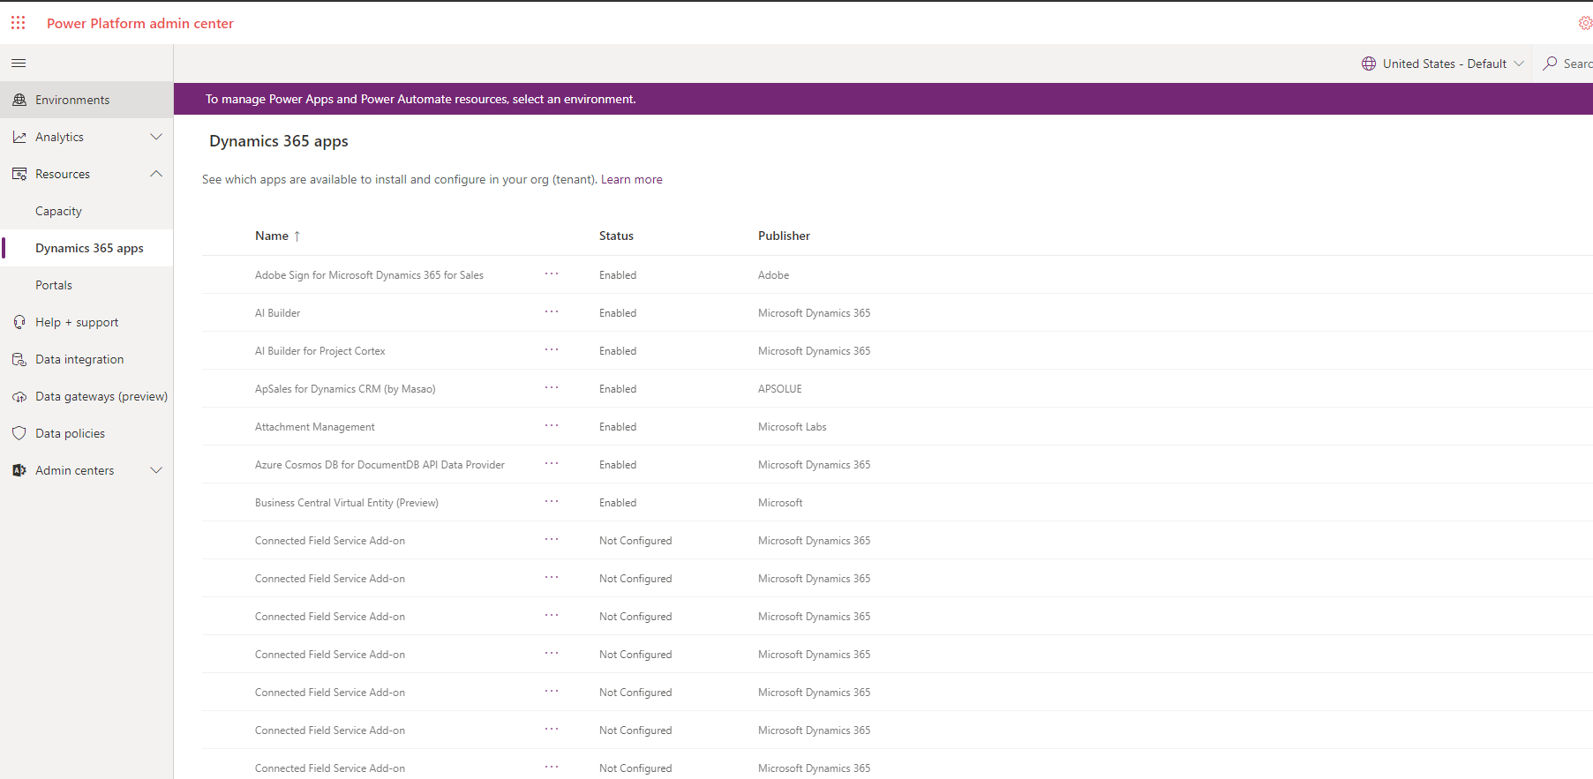
Figure 24: List of Dynamics apps

High Availability & Disaster Recovery
Few important concepts to understand before understanding the HA & DR
- Geography: Azure geography(GEO) is a defined area in the world that contains at least one Azure region
- Region pair: An Azure region is an area within a GEO, containing one or more DCs.
- Datacenters: Centers where resources are hosted
Broadly they can be visualized as follows:
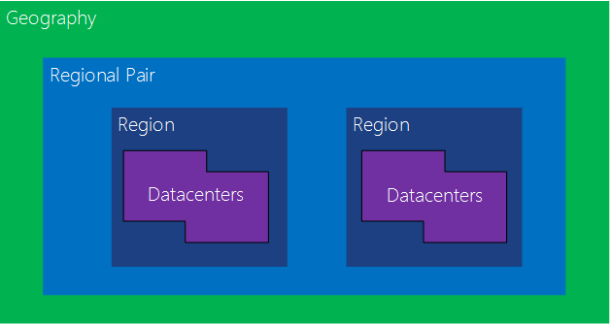

Few important points to note:
- Region Pairing: Each Azure region is paired with another region within the same GEO, together makes a regional pair. Azure serializes platform updates (Planned Maintenance), so that only one paired region is updated at a time.
For Canada Geo the Azure Regions are Central (Toronto) & East (Quebec City) (https://azure.microsoft.com/en-ca/global-infrastructure/geographies/)
- Disaster Recovery: D365 uses Azure GEO pairs for DR purposes. Availability when it comes to localized failover, is within the GEO. Azure we does not failover randomly between geographies
- Upgrades: Across the region pairs Azure serializes platform updates (planned maintenance), so that only one paired region is updated at a time.
- Outage Recovery: In the event of an outage affecting multiple regions, at least one region in each pair will be prioritized for recovery.

High Availability (intra-geo)

- Figure below shows how accessibility is managed in event of single component failure within a GEO
- There is No Single point of failure
- Azure is used wherever possible (DNS HA, SLB HA, SQL HA, Blob HA, Cosmos DB HA, Search HA)
- Conceptually the components in the system are very similar to what they've always been (traditional on-premise) it's just that in many cases D365 now relies on Azure to provide the services. For example -
  - Load balancers: Platform use a combination of app gateway moving towards s/w load balancer V2 in Azure. In a on-premise world, those were F5 devices
  - Compute Stack: Web, Jobs (Async servers), Sandbox, Reporting is provided by VMSS. Similar to physical servers spread across server racks in as on-premise world
  - Storage Stack: This is where D365 has changed the most in V9. Traditionally there were pile of SQL servers configured with Availability Groups using SQL high availability. In V9, platform heavily relies upon Elastic Pools

Figure 29: Intra Geo HA

Disaster Recovery (Computer Tier)
- Azure Location A is serving traffic in this case
- If Location A is down for whatever reason then Azure DNS is updated to point to SLB in Azure location B
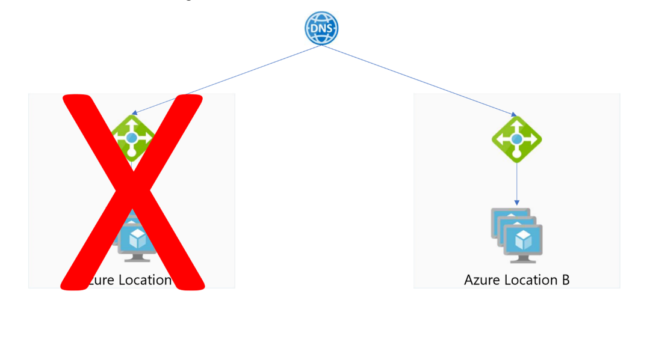
Figure 30: Computer Tier DR

Disaster Recovery (SQL - Production )
- SQL Elastic Pools operate in both the geographies and D365 has Async replication between Loc A and Loc B. There are LRS(Locally Redundant Storage) backups within Loc A handle by SQL
- If Location A is down then platform has Location B ready with up to data DB to serve the traffic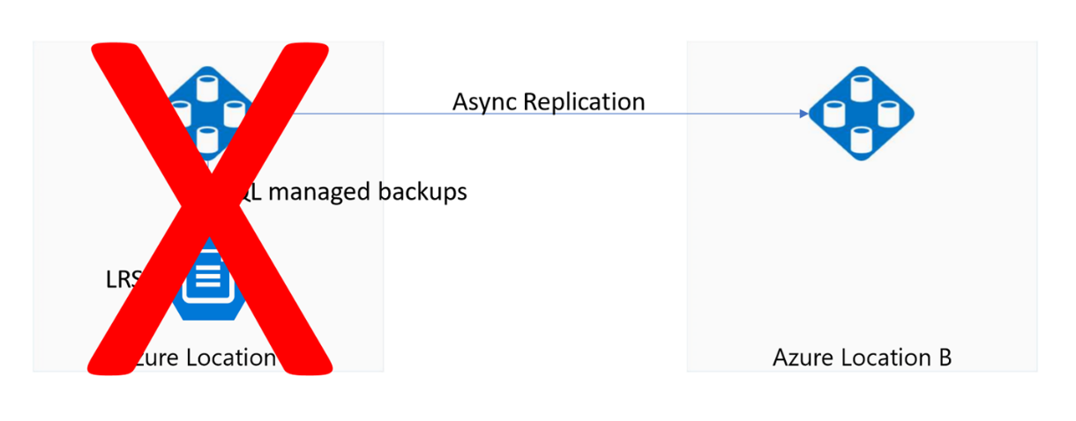
Figure 31: SQL Production DR

Non-Functional Requirements​
List all the project NFRs agreed with key stakeholders. They can be categorized as :
- Auditability
- Availability
- Compatibility
- Extensibility
- Interoperability
- Performance
- Recovery
- Reliability
- Scalability
- Security
- Transferability

Annexure​

Coding Standards and Best Practices
<List the coding standards prescribed by client on the project or as a SI bring the best practices recommended by Microsoft>

